Bird Lake Christian Academy Tuition

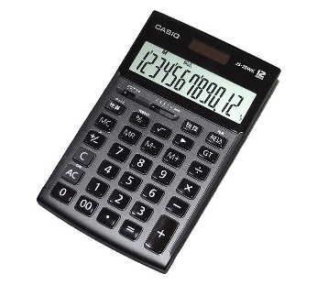

*A. Tuition per month (for those children who regularly attend*

*Bird Lake Wesleyan Missionary Church)*

First Child $135.00

Second Child $110.00

Third Child or more $85.00

*B. Tuition per month (for those children who do not attend*

*Bird Lake Wesleyan Missionary Church)*

First Child $160.00

Second Child $135.00

Third Child or more $110.00

Preschool $30 per student each day

Registration fee $25 per child

Each student will be charged $3.50 for each PACE used.

Repeat PACES cost $6.00

4. There will be a $25.00 fee per semester charged to each student. This fee will cover lab fees, PE Fees, Cafeteria expenses, medical supplies, party supplies, etc.

5. Assessment testing fees will be based on cost of tests